Roots for DP1 List #8

pseudo-
pseudoscience
(something that appears scientific, but isn’t)
pseudopods
(the feet-like extensions of amoebas)

PSEUDO- =
(prefix)

pseudonym
(a false name that writer’s use; e.g. Samuel Clemens wrote as Mark Twain)

pseudo-sophisticated
(appearing to be sophisticated but really isn’t)

auto-
autopilot
(a setting where a machine operates or drives itself)

AUTO- =
( )

nom- / nym-

tract-

-age

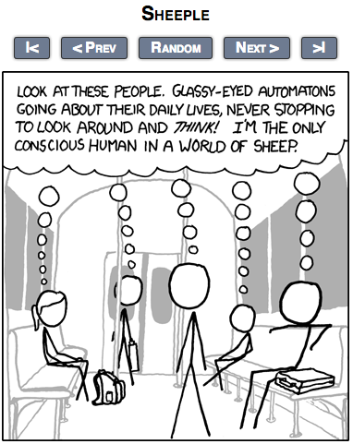
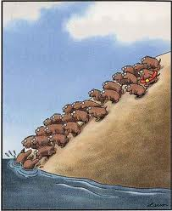

“lemmings”
& “sheep”
- If you believe
those pseudo-
scientific claims,
then you’re just
a lemming.

Prefixes |  |  | Roots |  | Suffixes
a-/ab- auto-  di-  in-/im-  intro-/intra-  inter-  co-/con-/com-  contra-  meta-  neo- |  | ob-  pre-  post-  pseudo- | ben-/bene-  cide- cog-  cred-  dict- dub-  duc-/duct-  host-/hosp- mal- | mania-  pac-/ plac-  scrib-/scrip- spect-  tract-  trans- viv-/vit- | -age  -er/-or  -tion  -ity  -ment  -ify  -ate  -ious/ous  -ent/-ant
Idioms | “cat out of the bag”; “sheep”; “lemmings”

List #7 Vocabulary:
- pseudonym (n): a false name used by writers to remain anonymous
  - “Mark Twain” and “Lemony Snickets” are two pseudonyms that are more well known than the writers’ actual names.
  - She wrote under a pseudonym to protect her identity.

- automaton (n): a machine acting like a human (or satirically the vice versa)
  - If we only read the opinions of others and never think for ourselves, we will become automatons.
  - She went about the preparations like an automaton.

- autonomy (n) / autonomous (adj): independence / independent
  - The purpose of school isn’t to fill your head with knowledge, it’s to make you an autonomous learner.
  - The small nation fought hard to achieve autonomy from its colonial rulers.

- nomenclature (n): the system of names for a given field
  - Biology uses a mainly Latin-based nomenclature to describe animals and plants.
  - It takes a good deal of study to become familiar with the nomenclature of Geology.

- antonym (n): a word meaning the opposite of another
  - The antonym of ‘utopia’ is ‘dystopia’.
  - The words “late” and “early” are antonyms.

- misnomer (n): a bad/misleading name
  - The word “peanut” is in some ways a misnomer since this food is not a nut.
  - “The Paradise Hotel” is certainly a misnomer; this place is anything but paradise!

- acronym (n): a word made from the initial letters of other words
  - The word RADAR is actually an acronym for RAdio Detection And Ranging.
  - The term ‘laser’ originated as an acronym for Light Amplification by Stimulated Emission of Radiation.

- intractable (adj): stubborn; unyielding; unmovable
  - I tried to convince students not to rely too much on technology, but they are intractable on the matter.
  - His niece was the only person who had any influence on that intractable old man.

- IDIOM: “lemming” & “sheep”: a thoughtless follower
  - Think for yourself! Don’t be a lemming/sheep!
  - The downfall of the economy can be blamed on the lemmings on Wall Street.

- vigor (n) / vigorous (adj): liveliness / lively
  - Getting plenty of sleep and eating right should provide you with vigor.
  - The only way to clean some items is with a vigorous scrubbing.

- amend (v) / amendment (n): to make changes in a text for improvement
  - I would like to amend my previous statement: “Please text me before 10pm!”
  - After the amendment of the contract, both sides agreed to sign.

- anecdote (n) / anecdotal (adj) : a short, personal story used as an example
  - If you use only anecdotal evidence in a research paper, you’re in trouble.
  - She told me some interesting anecdotes based on her travels in South America.

Master List for Teacher
pseudo-scientific
pseudonym
pseudomorph
pseudopod
pseudosophisticated

autopilot
automobile
automatic
autobiography
autocrat
autograph
autonomy

anonymous
nomenclature
acronym
antonym
synonym
misnomer
eponym/eponymous
heteronym
homonym

attract/attractive/attraction
traction
tractor
retract
distract/distraction
extract/extraction
contract/contraction
abstract
tractable/intractable

salvage
storage
forage
acreage
appendage
dosage

